Draft Webpage Mockup (Loyal 11-1-2026)
This is really amazing. I have very few substantiative comments.
Great job!!!!
- Title: maybe use “native plants and animals”
- Polynesians didn’t bring fire, they initiated the human-use of fire to modify habitat.
- Some of the recovery maps appear incorrect – they show more red units than they should. But, most of priority maps look OK.
- In the base map options, the imagery base should not include the PU boundaries – they coverup the underlying map info.
- In the Where and When section, under priority actions, combined priority actions across groups --- I would suggest redoing this section to start with:
  - Highlights of actions across groups
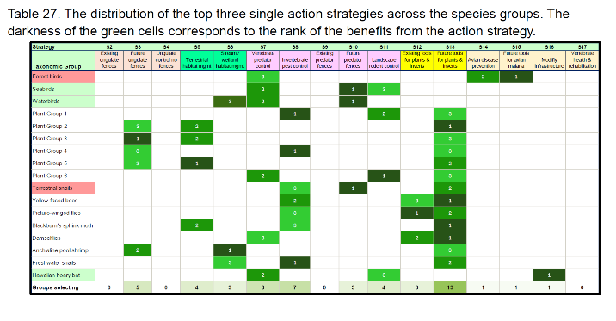
  - Then do the sequencing of actions – Peter may want to emphasize a shortened or different group of actions.

